November 8, 2017

Dear Women’s Ministries Coordinators:

Greetings in the precious name of Jesus! Thank you for a tremendous year for NCAG Women’s Ministries. During the spring, we enjoyed connecting with leaders and their teams throughout the state. Last month’s Live Fully conference was a milestone for us. With a record attendance of over 500 women, we worshipped, received the Word, prayed fervently, and laughed at the after party together. May we continue to embrace Living Fully in Him every day!

This packet contains valuable information for women’s ministry in 2018. We are excited about our partnership with Convoy of Hope Women’s Empowerment. This initiative ministers to women through Mother’s Clubs, Empowered Girls, and Micro+ which provides seed capital for small business. We are targeting El Salvador with our giving. There are several powerful videos on our website showing how these investments are changing the lives of women and their families. Please take the time to view them and share them with the women of your church. We are also planning a missions trip to El Salvador with Convoy Women in March. Additional information and applications are available on our website. You don’t want to miss joining this incredible partnership! We are also including a 2018 color, tri-fold TTW flyer, some Convoy Women’s brochures, and information on downloadable TTW resources.

Enclosed in this mailing is the 2017 Women’s Ministries Annual Report. With the holidays coming quickly, annual reports are the last thing we want to think about! Yet, I encourage you to grab a big cup of coffee or chai latte and take a few minutes to use the report as a self-assessment tool. Carefully consider where you are investing human, material, and financial resources. Then, look at the fruit of ministry in 2017. Taking time to reflect can help your team design women’s ministry for the future. I encourage you to go ahead and plan your entire women’s calendar for 2018. We are continually adding names to our email database for e-newsletters. Yet, email addresses often change. When completing your report, please give us your correct email and the correct emails for any women in your church who wish to be on our mailing list. Please return your report by January 16, 2018. All coordinators who return their report by the due date will be entered in a drawing for a free gift from our NCAG Women’s Boutique.

Another enclosure is the 2018 Missionary Adoption form. I urge your women’s group to adopt a missionary family in 2018. It is a wonderful way to provide encouragement and connect with what God is doing around the world.

Thank you for your monthly tithes and contributions to the North Carolina Women’s Department. Please know that your faithful financial support is ever appreciated and never taken for granted. Your faithfulness enables us to pursue excellence in ministry to the women of North Carolina.

Beloved leaders of women, my prayer over us is Colossians 1:23 that we will: “continue in the faith, grounded and steadfast, and are not moved away from the hope of the gospel….” May our faith and hope in Him be strengthened, and may we demonstrate this faith and hope through His love to our world in 2018!

Blessings,
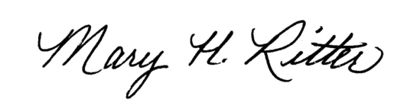
Mary Ritter
NCAG Women’s Ministries Director

