July 11, 2017

Dear Friends:

I am delighted to invite you to our annual NCAG Women’s Fall Conference. Women from across North Carolina will gather at CFA, Concord on October 6-7, 2017. Our theme for the weekend is Live Fully, and Becky Hennesy is our featured speaker. Becky is the Co-Pastor and Women’s Ministries Director of Trinity Church in Cedar Hill, Texas. This ministry broadcasts a message of hope, crossing generations and cultures. Her passion is to create a safe place for women to grow as they discover God’s fantastic, personal will and plan for their lives. Thus, she propels each woman to find her unique place of service to God, home and community. Becky was also recently appointed Chaplain of WNBA Dallas Wings. We are thrilled to welcome her to North Carolina. You will not want to miss her anointed, powerful ministry!

During our time together, we will experience worship, teaching, prayer, and friendship. The CFA worship team will be leading us in worship. The opening service will be Friday evening at 6 pm. Registration and the conference boutique, however, will open at 4 pm. Following the evening service, we will enjoy our After Party Fiesta which includes food, comedy, great prizes, and loads of fun. On Saturday morning, we will celebrate Touch the World missions and hear about what our giving is helping to accomplish in North Carolina and around the world. Then, we will offer inspiring breakout workshops. Finally, we will connect with one another over lunch and culminate our weekend with Becky sharing the Word in our closing service.

Concord offers wonderful shopping and restaurants. Our conference, however, is during a race weekend at the Charlotte Motor Speedway. We encourage you to come early and allow for extra travel time due to increased traffic. We will post helpful driving routes on our webpage and social media to help expedite your trip. Please make your hotel reservations early. Due to the race, you will not find affordable hotel rooms outside of our room blocks. Our preferred conference hotel is Great Wolf Lodge. They have some rooms that sleep up to 6 people, and your group gets access to the water park for extra fun. With Great Wolf and the nearby shopping, some groups may wish to plan for an extended time of recreation as part of your weekend.

Enclosed you will find 2 posters, registration forms, hotel information, and a general schedule for the conference. This year we are offering a special registration rate of $25 for women aged 18-29, and your group gets 1 free registration for every 10 paid registrations. Watch our website, www.ncwm.org, and Facebook group, NCAG Women for a promotional video, workshop descriptions, boutique items, directions, fun giveaways and more leading up to the conference. If you have any questions, please contact Amanda Hoggard at 919-965-0225 ext. 237 or ahoggard@ncag.org. Please don’t miss what God is going to do among us - I can hardly wait to see you!

With anticipation,

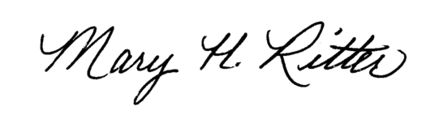
Mary Ritter
NC District Women’s Ministries Director

