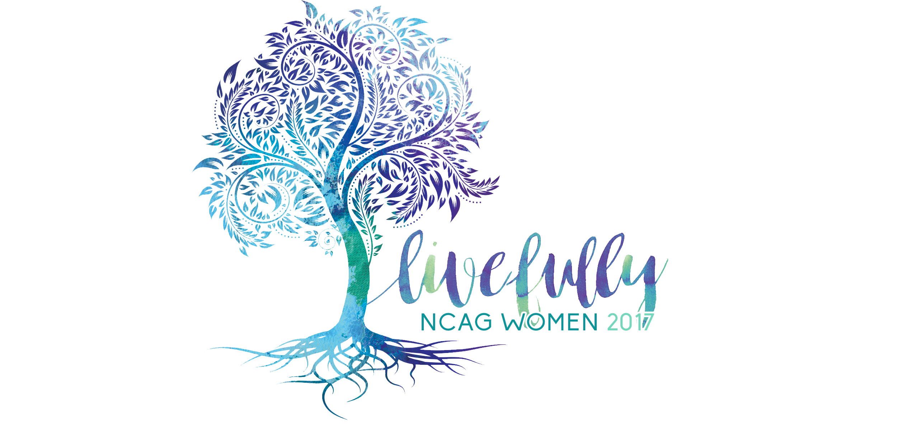

October 6–7, 2017
CFA, Concord
INDIVIDUAL REGISTRATION

YOUR DETAILS

First Name_________________________________ Last Name___________________________________

Address____________________________________________________________________________________

City_____________________________________________ State________________ Zip__________________

Phone (home)________________________________ Phone(cell)______________________________

Date________________________ Email__________________________________________________________

**REGISTRATION DEADLINE SEPT. 19**

CHURCH DETAILS

Do you attend Church?_____________ If ‘yes,’ Church Name:______________________________
Church City____________________________________ State__________________ Zip_________________

Will you be attending with a group? Y_______ N_______

If yes, please list Church and Leader______________________________________________________

Payment Options: (check one) Check________ Check #__________

Payable to: NCDC, Memo: Women’s Fall Conference

Visa_______ Mastercard ______

Name on Card___________________________________________________________________
Card Number ________________________________ Expiration Date_____/_____/_____
Security Code (3 digits on back of card)_____________
Full Address of Cardholder____________________________________________________
Signature of Cardholder_______________________________________________________

TOTAL:_____________
Or register online at: www.ncwm.org

Registration cost includes Live Fully surprises, services, Friday night after party, workshops,

and lunch on Saturday. Registration must be received in the Women’s Ministries office by the deadline. Registrations mailed after the deadline add a late fee of $10.00 per person. You will need to make room reservations with the hotel of your choice. If you have any questions, please contact the WM office at 919.965.0225 ext. 237 or ahoggard@ncag.org.

